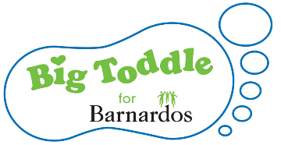

SPONSORED TODDLE EVENT – 10th May 2021
SPONSORED SAFARI WALK AROUND WESTMINSTER PARK

Dear parent/guardian

We are hosting a sponsored walk to raise money for Barnardo’s, and would really value your support. The Barnardo’s Big Toddle is the UK’s biggest fundraising event for under 5’s. Many thousands of toddlers take part in sponsored walks every year and have tons of fun while helping vulnerable children. The theme for this year’s Big Toddle is going to be Safari!

On 10th May we will be taking the children out group by group into Westminster Park for them to do their sponsored toddle to help raise much needed funds for Barnardo’s.

We have included a sponsorship form with this letter and it would be great if children could get as many sponsors as possible to help us to raise as much money as we can. Please help us by helping your children to ask friends and family for donations. Please complete the slip below to give your child permission to take part.

Kind Regards

Elizabeth Hulse, Head Teacher
………………………………………………………………………………………………………………………………………………………………………………

Barnardo’s Sponsored Toddle – 10th May 2021

□ I give my child Name:………………………………………………………………. permission to join in with the sponsored toddle on 10th May

Date:………………………………………………………….

