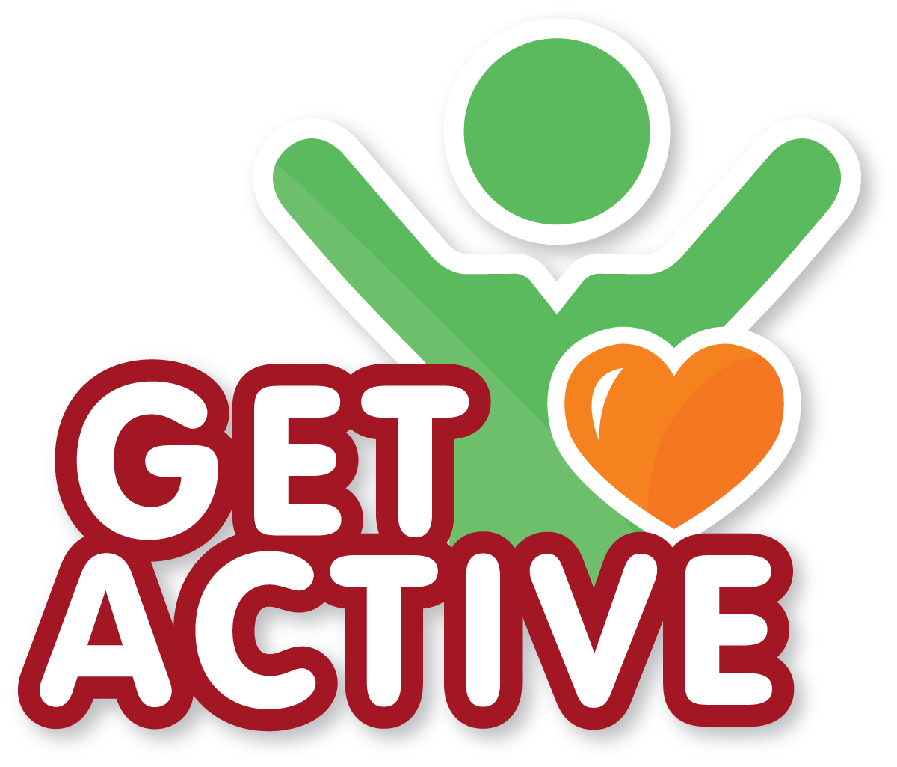


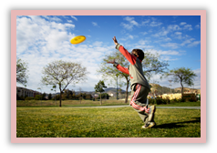


- Start the day with a dance routine!

- Organise active group games (e.g. tig, duck-duck-goose, stuck in the mud).

- Give the children a selection of equipment (e.g. hoops, cones, balls) and task them to create an activity course for others to complete.

- Go on a treasure hunt walk – perhaps in a local park or wood. Task the children to collect a selection of ‘treasure’ during the walk (e.g. a stick the size of a finger, a small white stone).

- Set mini skills challenges to be completed during the week (e.g. throw a bean bag to a friend and back 3 times without dropping it, bounce a ball 3-5 times without stopping).

- Play a game of sock skittles! Set out a selection of empty plastic bottles and task children to bowl them over with balled socks!

Get under 5s active for at least 3 hours a day. Walking, active play and structured activities (like ball games) all count!
- Being active helps keep children’s hearts healthy.
- It strengthens children’s developing muscles and bones.
- It helps children to have a healthy bodyweight.
- It can support development of coordination and social skills.
© British Nutrition Foundation 2018
To find out more about activity for children

- NHS advice on physical activity in under 5s: https://bit.ly/2yzkcRN

- Information from BNF on children’s physical activity: https://bit.ly/2rRalmx

Why is it important for children to get active?

Get active activities for children

- It is important that children, unless sleeping, are not sedentary for long periods.
- Do you make sure children do energetic activity throughout the day, every day (e.g. active play, dancing, climbing)?
- Do you provide exercise equipment (e.g. hula-hoops, balls) during playtime for the children to use?
- Do you minimise TV and screen time?

Get active at your nursery

