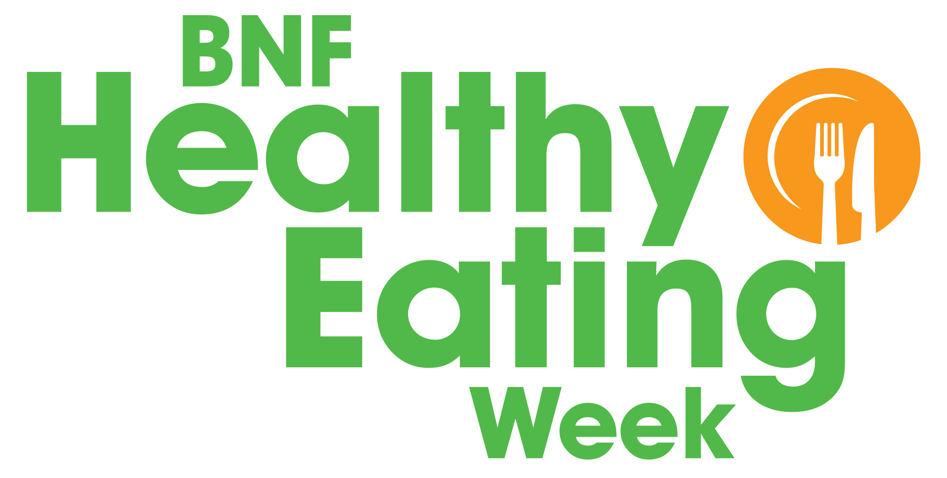
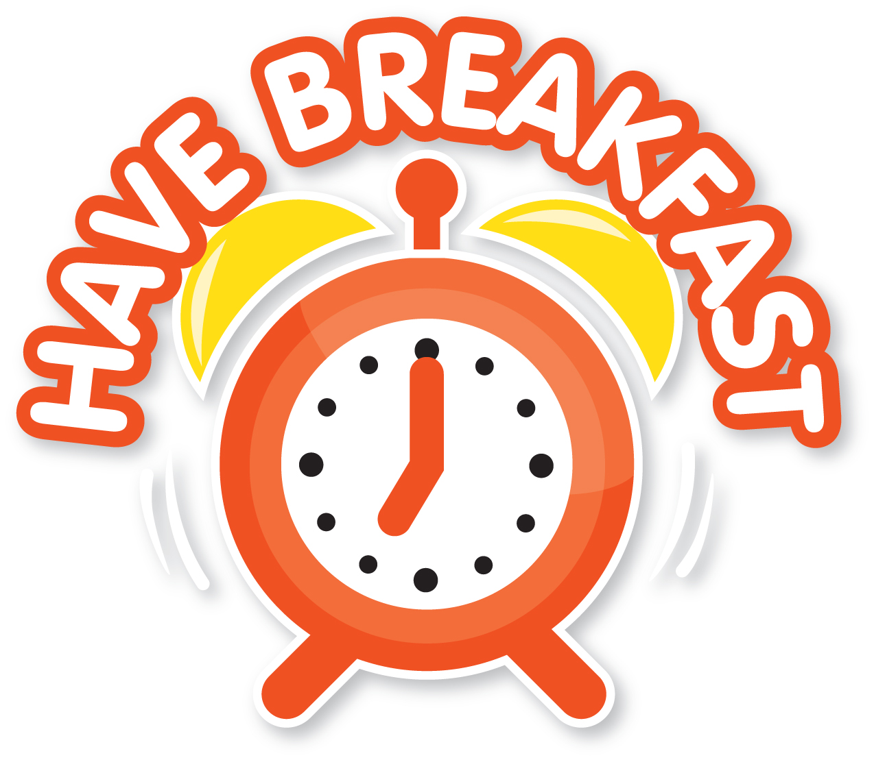

Offer a healthy breakfast every day that includes wholegrain foods, a drink and at least one portion of 5 A DAY!
Why is it important for children to have breakfast?

- It helps to get the day off to a good start and provides energy for the day ahead!

- It provides nutrients important for good health – such as starchy carbohydrates, fibre, vitamins and minerals!

Breakfast at your nursery

Are your cereals low in salt and sugars?

Do you offer fruit (e.g. sliced banana on cereal) or vegetables (e.g. mushrooms on toast) at breakfast?

Do you offer an unsweetened drink with breakfast (e.g. water or milk)?

Do you offer wholegrain foods (e.g. wholegrain cereals, porridge and toast)?

Have breakfast activities for children

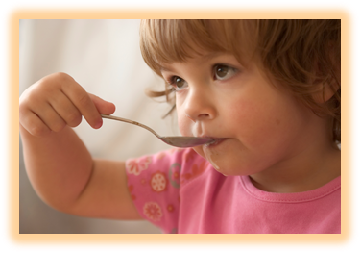
Use our Tasty toast session notes and resources to get children:

topping their own toast;
talking about breakfast foods and drinks by playing a game of breakfast pairs;
keeping track of what they have for breakfast at home with a breakfast diary.

Go to: HYPERLINK "https://bit.ly/2IQ2gsc" https://bit.ly/2IQ2gsc

- Information from BNF on nutrition for toddlers: https://bit.ly/2geFZqB

- 5532 – information about toddler-sized portions: https://bit.ly/2IvXXim
To find out more about healthy breakfasts for children

