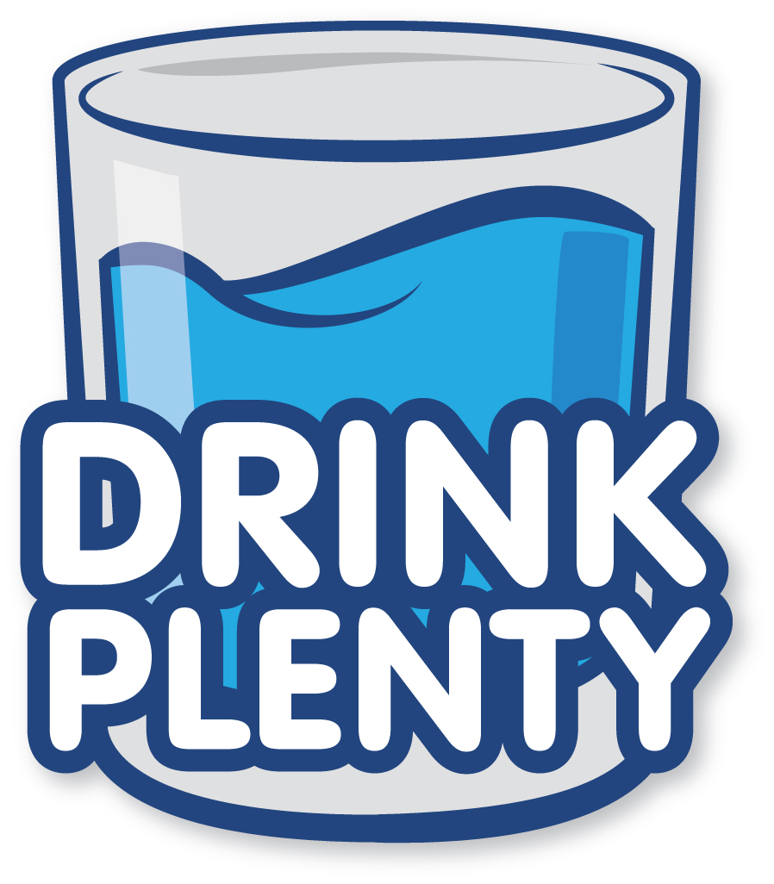
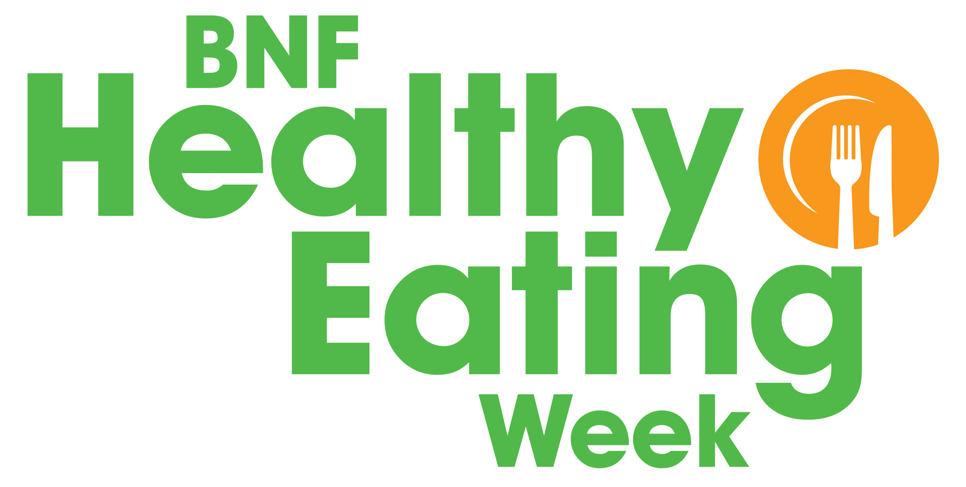

Offer at least 6-8 unsweetened drinks every day – water and milk are healthy choices!

Why is it important for children drink plenty?

- Water is essential for life and needed for lots of bodily functions such as regulating body temperature.
- Water is lost through sweating, breathing, and going to the toilet.
- Dehydration can cause lack of concentration and sleepiness.
- Young children may forget to drink so it is important to provide water throughout the day.

Drinking plenty at your nursery

- Sugary drinks can damage teeth; water and milk are the best options for toddlers.
- Fruit juices are high in sugars so it is best for young children to drink water and milk. If offering juice, it’s best for this to be with mealtimes and diluted with water.
- Offer water and encourage drinking throughout the day to ensure children stay hydrated.
- Make sure children are drinking plenty when active or when it’s hot.

Drink plenty activities for children

- Hydration station - create a water station with jugs of water and a selection of ‘additions’, (e.g. ice cubes, slices of cucumber, orange and lemon, fresh mint leaves). At snack time, invite the children have some water and choose some additions!
- Set a hydration goal – challenge the children (as a group) to have the equivalent of a bath full of drinks during BNF Healthy Eating Week – that’s around 80 litres! Draw a big bath chart and give children a blue dot stickers to attach each time they have a drink!

To find out more about hydration for children

5532 – a healthy eating and drinking guide for toddlers: https://bit.ly/2IvXXim

Information on healthy hydration for children: https://bit.ly/2rRKoDD

