
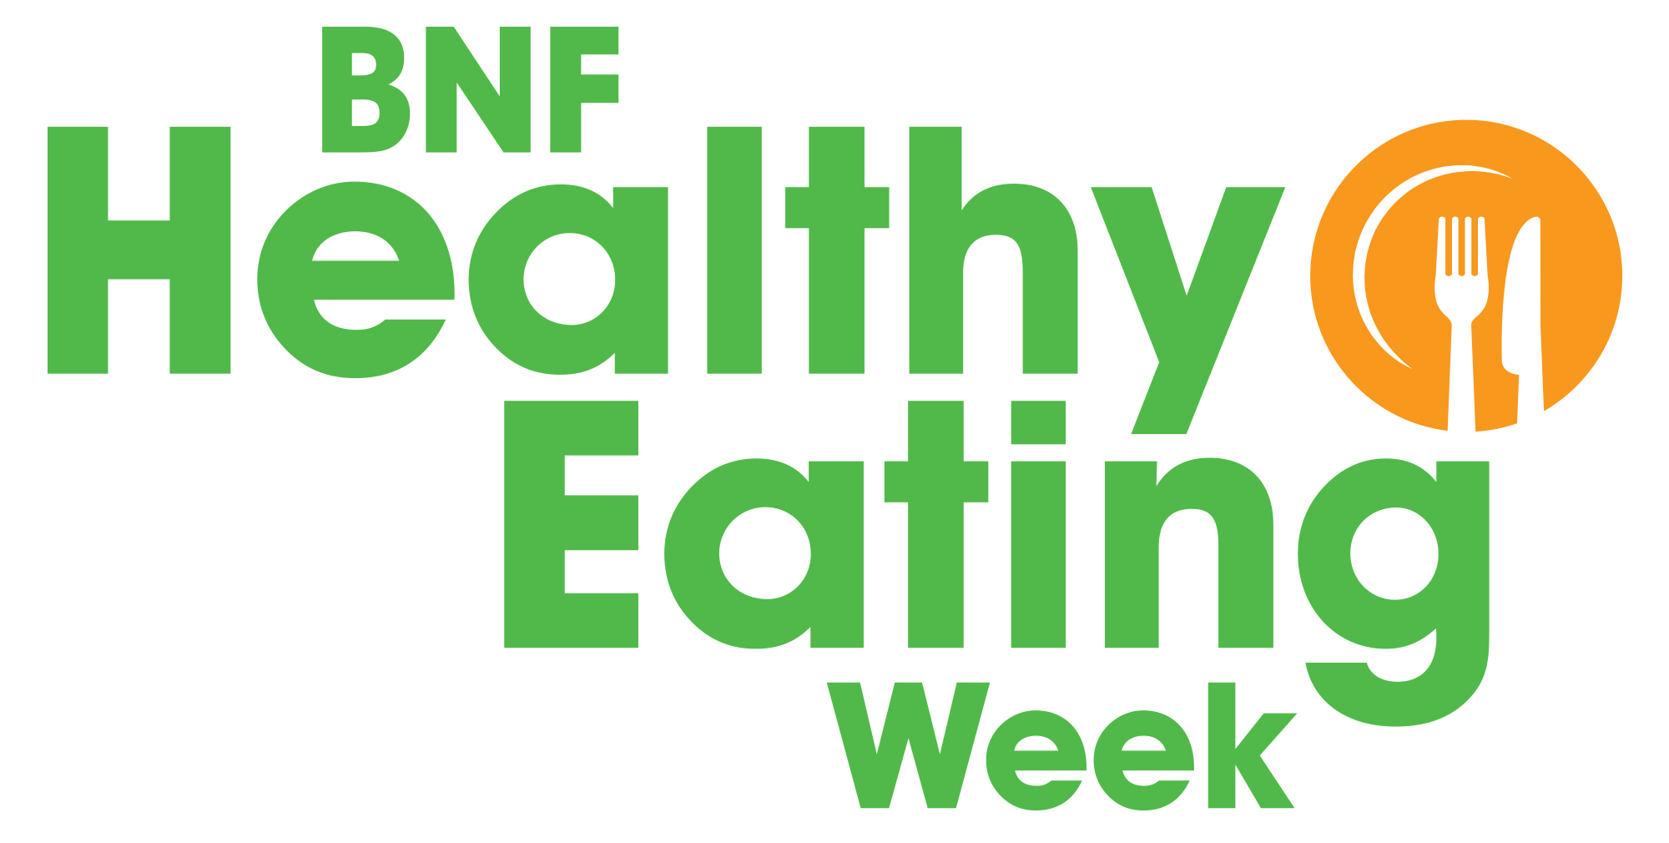

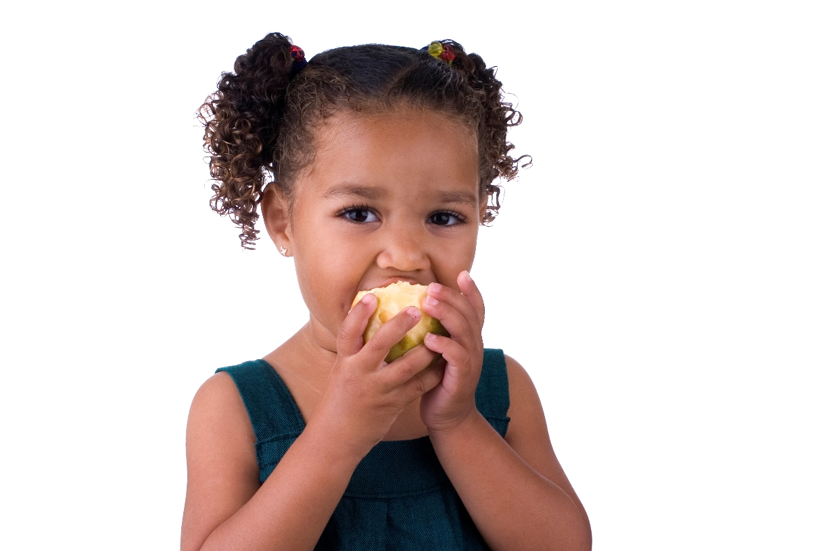

Offer a variety of fruit and vegetables every day!
5 A DAY at your nursery

- Fresh, frozen, canned and dried fruit and vegetables all count (dried fruit should be restricted to mealtimes, to reduce impact on teeth).
- Offering a variety of fruit and vegetables is important as they provide different amounts and types of nutrients.
- Did you know beans and pulses count towards 5 A DAY (but only once)?
- Do you offer fruit or vegetables with each meal and as snacks?
- Fruit juice is high in free sugars so it is best for young children to drink water or milk.

Why is it important for children to have at least 5 A DAY?
- Fruit and vegetables provide a range of vitamins, minerals and fibre, which are important for good health.
- Eating at least 5 A DAY can help reduce the risk of developing conditions such as heart disease in adulthood.
- Giving children lots of opportunities to eat a variety of fruit and vegetables will help them learn to like them!

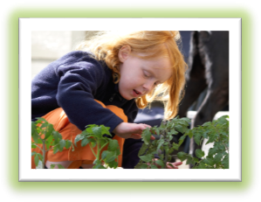

Have 5 A DAY activities for children

Use our Delicious dips and dippers session notes and resources to get children:
- learning about fruit and vegetables that can be eaten as snacks;
- making a dip to eat with a selection of vegetable dippers;
- tasting a variety of vegetables.
Go to: https://bit.ly/2GqFwd3

© British Nutrition Foundation 2018
To find out more about 5 A DAY
for children

- Healthy eating for toddlers: https://bit.ly/2geFZqB
- 5532 – information about toddler-sized portions: https://bit.ly/2IvXXim
- NHS information about 5 A DAY:
https://bit.ly/2ifPtAL

