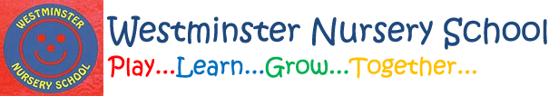

For your information:
A child from your child’s group has been sent home today with symptoms which may be Coronavirus related.
The parent has been advised to get a test and we will inform you if we have any news about results and if a case is confirmed.
Please watch your own child carefully for any symptoms:
- High temperature
- Persistent cough
- Loss of sense of smell or taste
Please ring if you decide to keep your child at home following this information.

