Curriculum intent for children:
I am learning | I can learn by playing and exploring.  I can play and learn inside and outside. It is fun!  I can try my best to do new things.
I can communicate | I can listen to others.  I can show you what I think, want or need.  I can understand other people and respond.  I can try out new words and ask questions.
I learn in my own way because I am unique | I am curious. I like to find things out!  I can remember things I’ve done before.  I can make links with things I’ve seen or done before.  I am trying new things and I don’t give up if it’s tricky.
I am supported  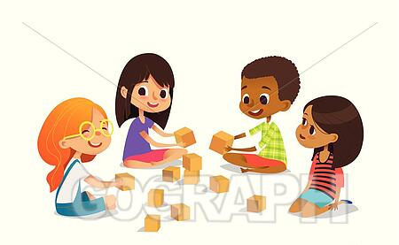 | I know how I am feeling and what or who helps me.  I can share and work in a team.
I am included | I am me; special and valued.  I can play and learn with lots of different people, making new friends.  I know we are all different and that’s ok.

